# Assignment 2: Neural Networks for Estimation

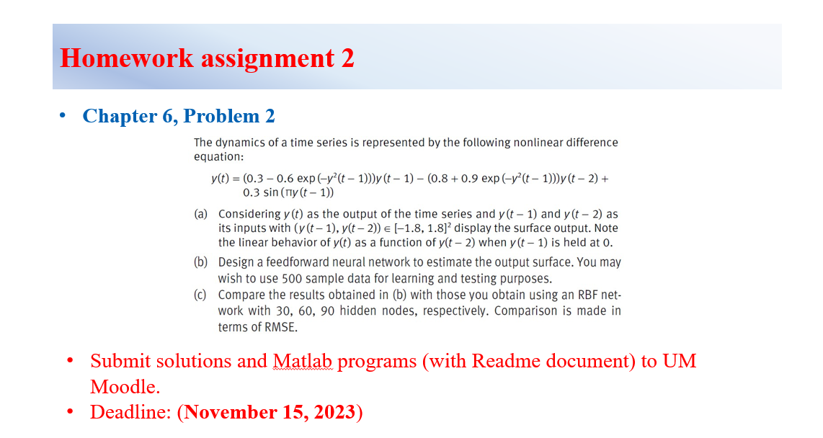

## Solution: Problem 1

### Problem Analyzing

By plotting the target function:

Which shows:

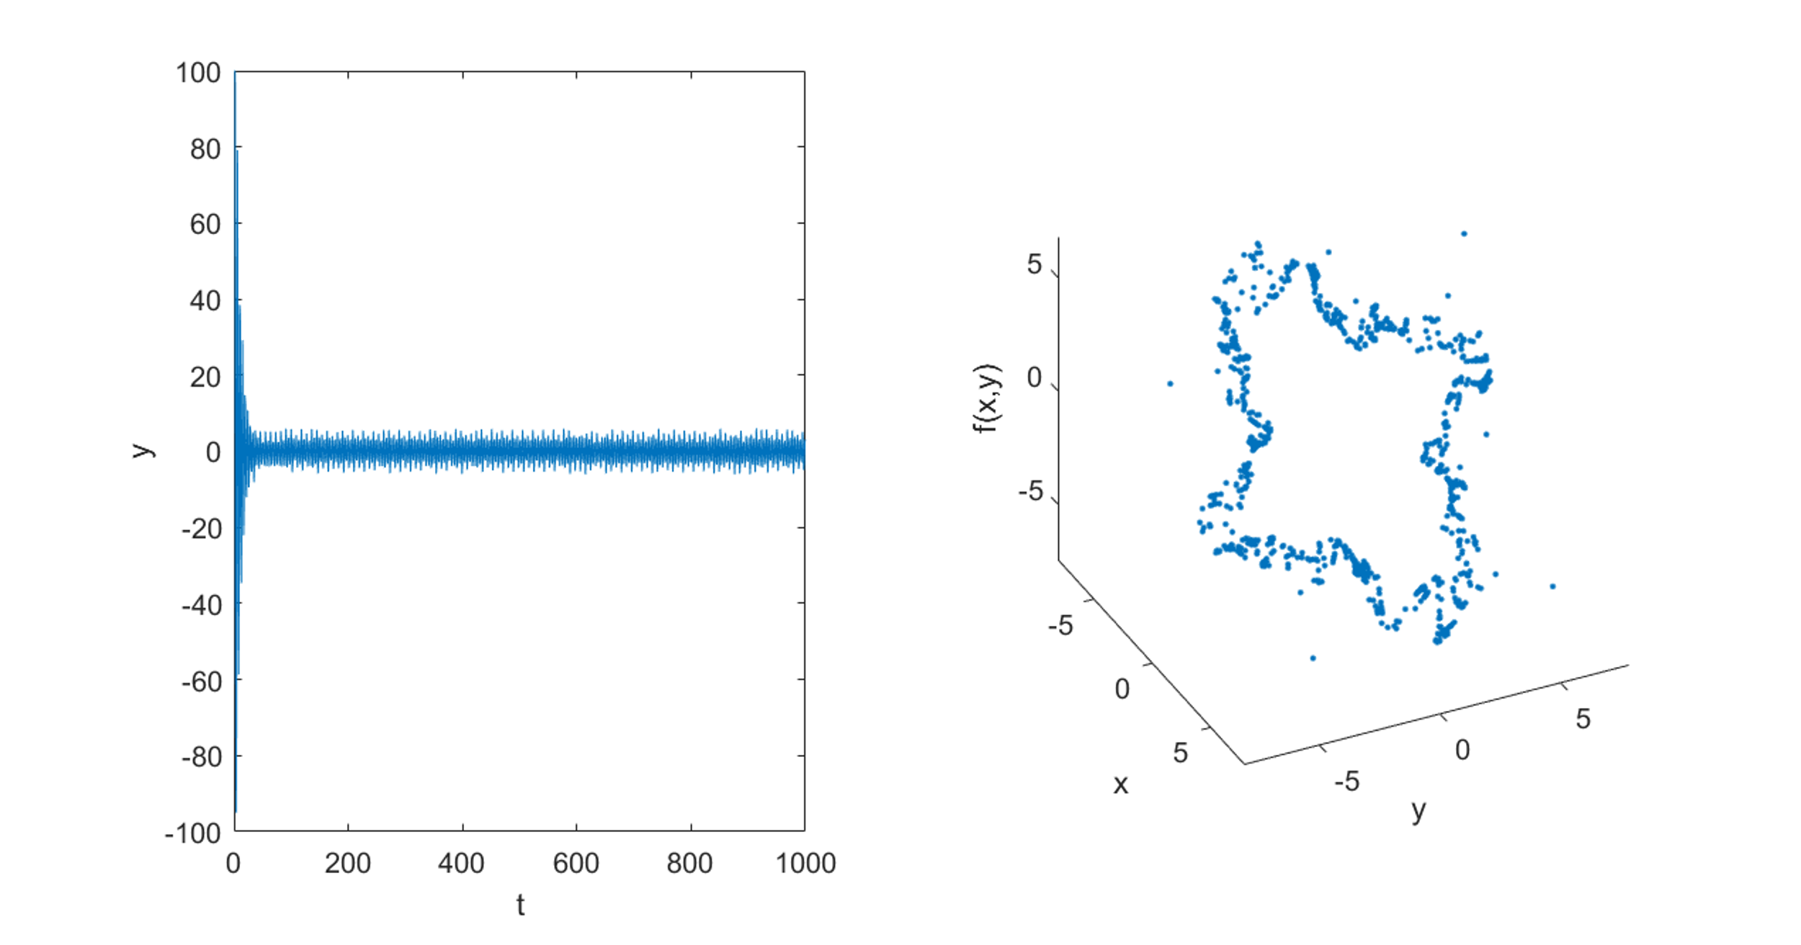

Figure : Initial value = (100,100)

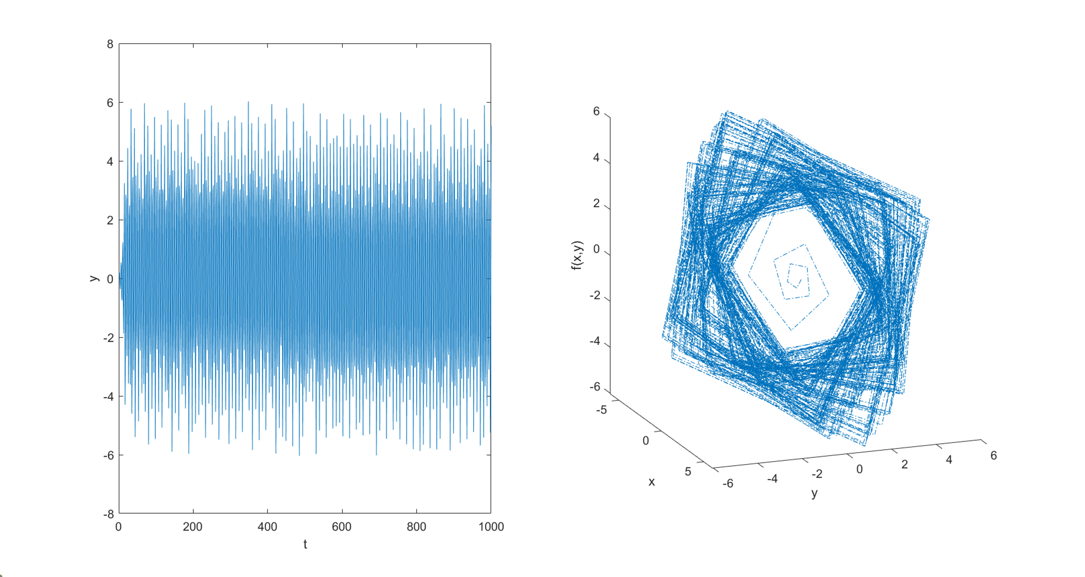

Figure : Initial value = (0.1, 0.1)

Notice that the trajectory always converges to a ring-like region, which is inside region , thus we focus on this region.

### Simple Network for Function Fitting

Here we use Neural Network Fitting (nftool) from MATLAB.

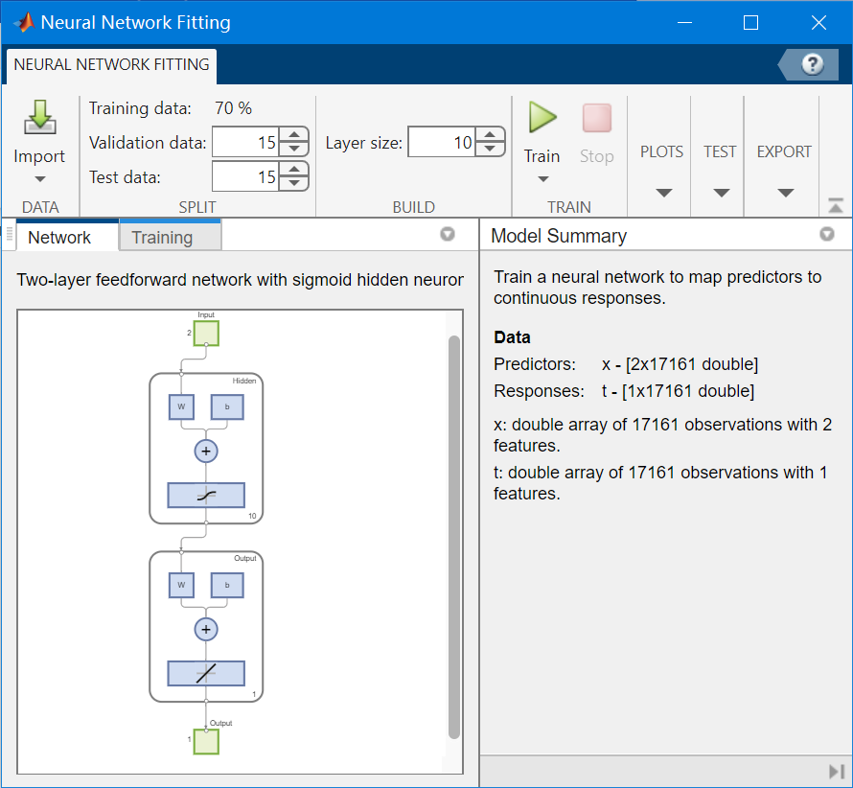

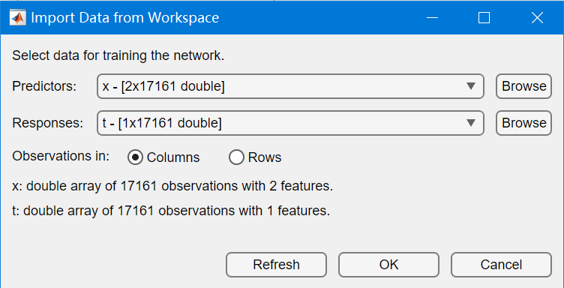

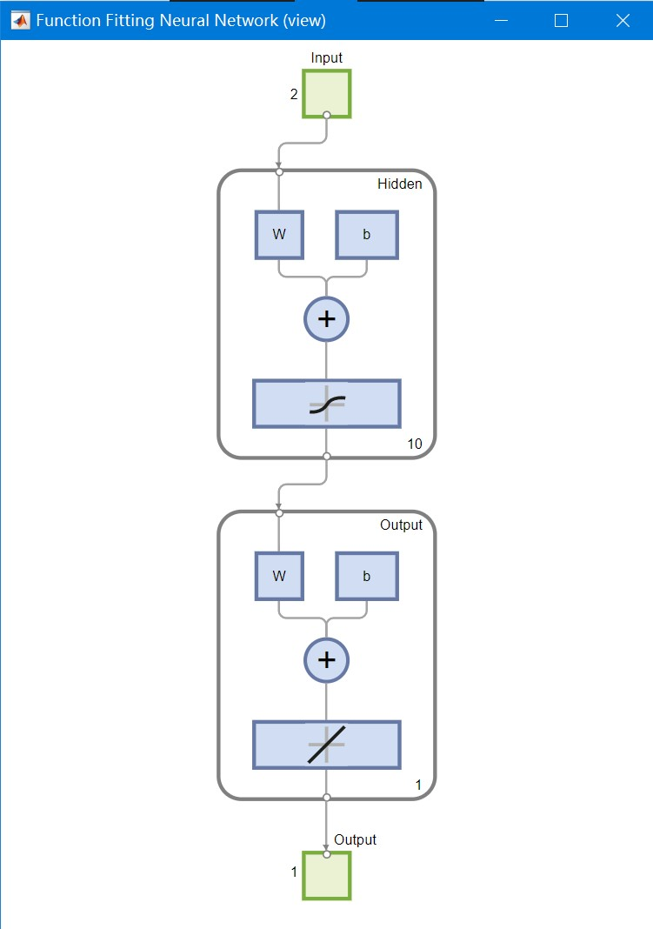

This procedure is converted to code in **genffn**.

### Result Assessment

Compare the surface of the FNN and the original function.

